* 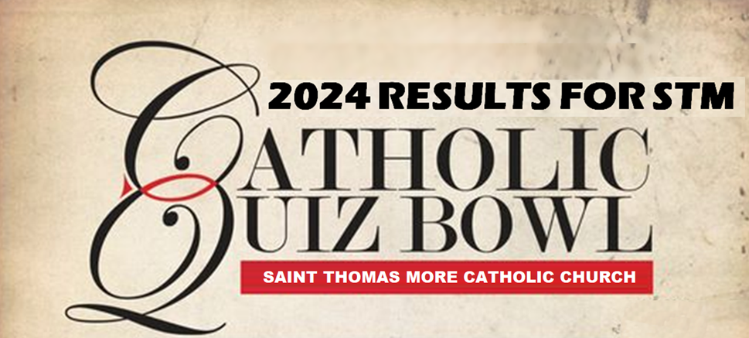**For Middle school students registered in Pastorate 8.**

**---CLICK HERE---**

* **Four rounds of questions with 24 questions per round.**
* **Team competition with 3 to 6 per team.**
* **Medals awarded to 1ST, 2ND, & 3RD place teams.**
* **Please have your team checked-in and seated in the STM Social Hall before10am.**
* **To register, contact NATALIE COOK, 605-692-8309, coordinator@stmbrookings.org**
* ***Topics this year:  saints, miracles, Mass parts, church building, colors, numbers, seasons.***
* **Sponsored by your local Knights of Columbus, Council #3640.**

**1st Place: “The Inquisitors”:   
Cecilia Moriarity, Gideon Gauer, Joseph Moriarty**

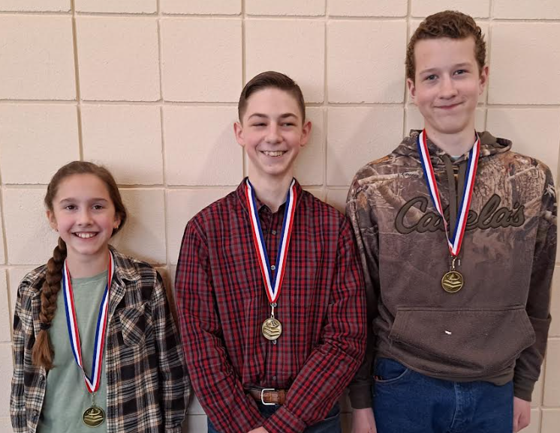

**2nd Place: “Daughters of the King”  
 Kallie Ryland, Aly Bacher, Faith Bacher, Catie Michna…**

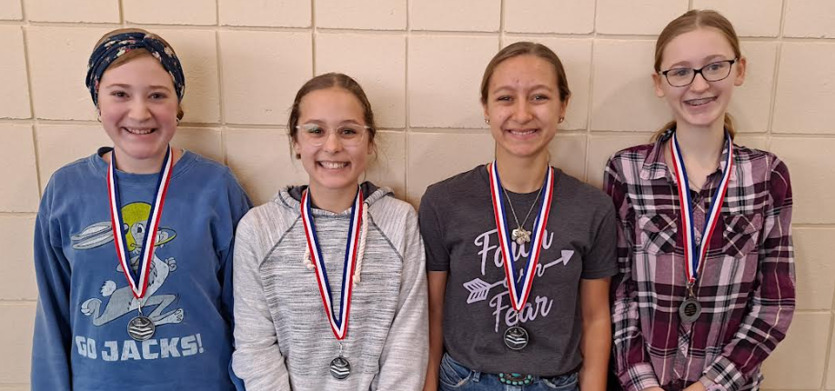

**3rd Place: “St Michael’s”  
 Dane Olson, Jacob Novotny, Holden Larson…**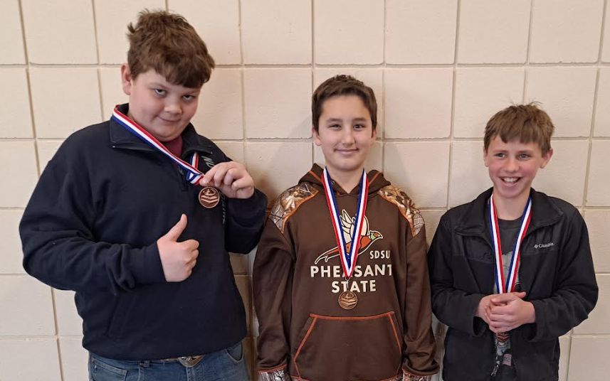

**Also competing: “The Apple’s Crew”  
 Kale Nelsen, Cayden Elsinger, Cooper Drawdy, Hayden Smidt**

